Connor Leu (ccl2396), Abdon Morales (am226923), Christopher Solis (CMS8862)

Part 1
Goal:
In Part 1 of this lab, we aim to evaluate the validity of the model of uncertainty propagation. We predict that the model will work and the mass multiplied by the distance to the mass on one side of the pivot will equal the mass multiplied by the distance to the mass on the other side of the pivot.

Method:
We will attempt to minimize the initial error as best as possible to thus minimize the error propagation.

There is likely some room in the placement of the meterstick on the pivot point, but given our measuring tools and lab equipment, we think it’s probably fine if we’re within +/- 0.5cm. The level on the top of the meterstick helps inform us about the level of the meterstick. Given this, we don’t estimate needing to account for the half-cm error on the meterstick positioning.

We want to test if:
$m_{1}*x_{1}=m_{2}*x_{2}$.
From an existing physics perspective, we want to validate torques.

We will be computing error propagation through partial derivatives of the form
$δy_{total}=√(δy_{1})^{2}+({δy_{2})}^{2}+...$
Where:
$δy_{i}=f'(x_{i})dx$
Per our lab lecture, the total error value is:
$δf=\sqrt{\sum_{i=1}^{n}{}(\frac{δf}{δz_{i}}*δz_{i})^{2}}$
This computation of our total error allows us to see how much error propagates throughout the experiment, which is what we can use to evaluate the accuracy of our model. We will also compare the T-scores of the torques to make sure they are as close as possible.

Since we want to check the model in its entirety, we want to check multiple ranges of weights and distance values to see if $m_{1}x_{1}= m_{2}x_{2}$ no matter what. We are treating the masses as digital measurements, so their error is always going to be +/- 0.01 gram, while the distance measurements will always be +/- 0.05cm.

Data

The data we collected was across multiple ranges of masses and distances from the center point.

The measurement error on the distance is 0.05cm, or 0.0005 meters; the measurement error on the masses is 0.01g, or 0.00001 kg.
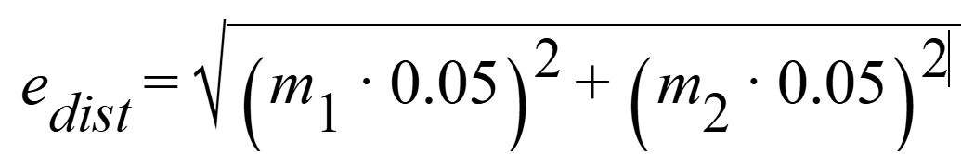
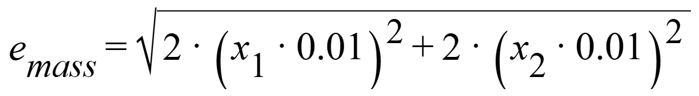
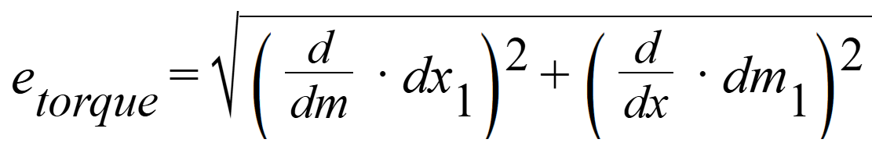
eDist = 0.014142cm
eMass = 0.004g
We need the second pair of $(x(1))$ in the mass computation to account for the hangers.
The distance measurements are measured by distance from the pivot, not from beginning of meterstick. The error calculations account include the transformation of data into SI units (kg, m)
Mass 1(g) | Mass 2(g) | X1 (cm) | X2 (cm) | Balanced? | error(T1) | error(T2)
200g | 200g | 20cm | 20cm | Yes | 0.0001  N*m | 0.0001  N*m
100g | 50g | 21.81cm | 40cm | Yes | 0.000109  N*m | 0.0002  N*m
20g | 50g | 48cm | 24cm | Yes | 0.00024 N*m | 0.00012  N*m
100g | 200g | 38cm* | 20cm | Yes | 0.00019 N*m | 0.0001  N*m
* the 38cm was calculated to need to be 38.81cm, but we had to ACTUALLY place the 100g mass at the 12cm marker to balance it.

We now compute the T-scores for the errors per trial. We identify these through the formula
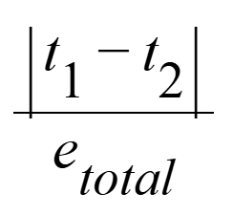
Where:

Mass T-Scores
200g and 200g | 0
100g and 50g | 0.04408
20g and 50g | 0
100g and 200g | 0

Conclusion

The main concern with reducing our uncertainty was the limits of our measurement devices. If we could further reduce the uncertainty of the measurements, we would drastically reduce our propagated uncertainty due to how the errors are calculated. Since they multiply the measurement error, the smaller the better.

The T-score table is a very good indicator that the torques are balanced properly, i.e. that the model is correct. Our only non-zero T score was the trial between the 100g and 50g mass. We can attribute this non-zero value to both systematic error (human error [measurements]), and random error (variations in the masses / measuring devices).

Part 2
Goal:
In Part 2 of this lab, we aim to determine the mass of an unknown object. We will be using a refined version of the model we analyzed in Part 1. We predict that the mass of the unknown object will be 80g or less given on physical observations and provided by the bubble level tool.

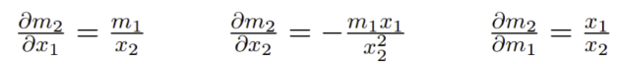
We will use the above partials in computing the error propagation of this experiment.

Method

To identify the unknown mass, we will be moving a 100g weight along the meterstick until the level is balanced. In order to minimize our error, we will redefine the partial derivatives we are using in our error calculations. We fixed the keys at a distance of 30cm from the pivot.

Data

The meter stick was levelled when the 100g mass was at 26.1cm from pivot. The corresponding torques are:
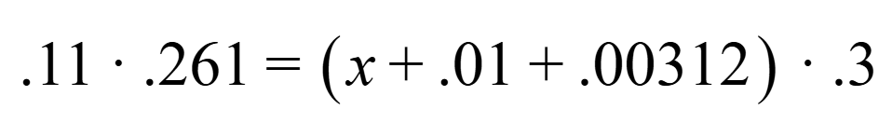
Where 0.11 is the 100g mass + 10g hanger, X is the unknown key mass, 0.01 is the hanger mass, 0.00312 is the mass of the clip we used to attach the keys to the hanger.

We compute a mass of 82.56g from the equation. The measured mass of the keys was 82.58g. We are within 0.02g of the true value.

We use the original partial derivatives from Part 1 for our error calculation for the 100g mass, since all of its values are known. However, we use the new partial derivatives for Part 2.

Error of 100g: ~0.000109 N*m (this computation is unchanged from previous calculations.)
Error of keys: $\sqrt{{\left(\frac{0.11}{0.3}\left(0.05\right)\right)}^{2}+{\left(\left(-\frac{\left(0.11\right)\left(0.3\right)}{{0.3}^{2}}\right)\left(0.05\right)\right)}^{2}+{\left(\frac{0.261}{0.3}\left(0.01\right)\right)}^{2}}$= +/-0.027348 N*m of error

We obtain a T-score between the two torques of: 0.002152
Given that this is significantly < 1, this is a very good indicator that our calculations were spot on, as well as the model being accurate.
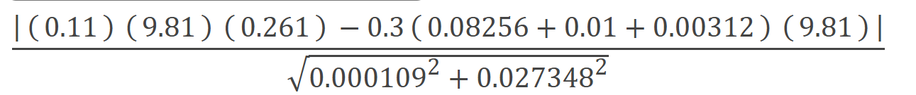

Conclusion
Since the formula for torques are linear, it makes sense that our measured/computed mass error is almost identical to the calculated error from the error propagation formula. There’s still measurement error, given we are using analog measuring tools for the distances and making educated estimates. For future iterations we should try to use more precise distance measurement techniques. Again, since the total error value grows directly based on each individual measurement error, the better we minimize each error, the smaller the total propagated error is as well.

We wanted to include all of the more specific partial derivatives for the error propagation so we could be more specific in our error definition for this problem. If we picked the standard derivatives, we might have gotten a smaller error value, but it might not have been as accurate.

